1. **CMPE 240 Experiment 6 Preliminary Work**

Step 1: Design circuits with minimum number of components for each function of the

ALU (This section should consist four circuits for each functionality of ALU) Show internal representation of each component as well. For example if you are using a full adder, draw inside of it as well. If you are using a component more than once, it is enough to draw inside of it once. You can represent repeated ones as black boxes providing their input/output labels clearly.

a)

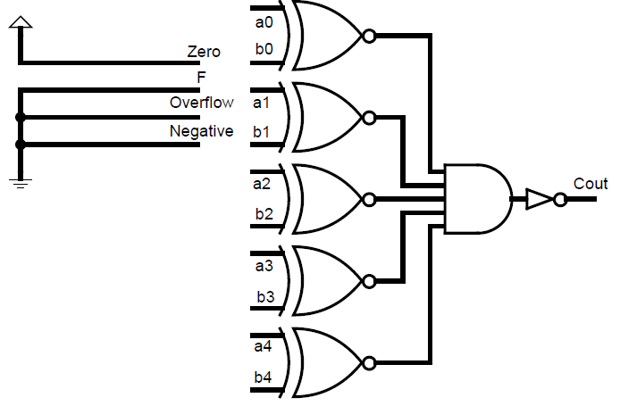

b)

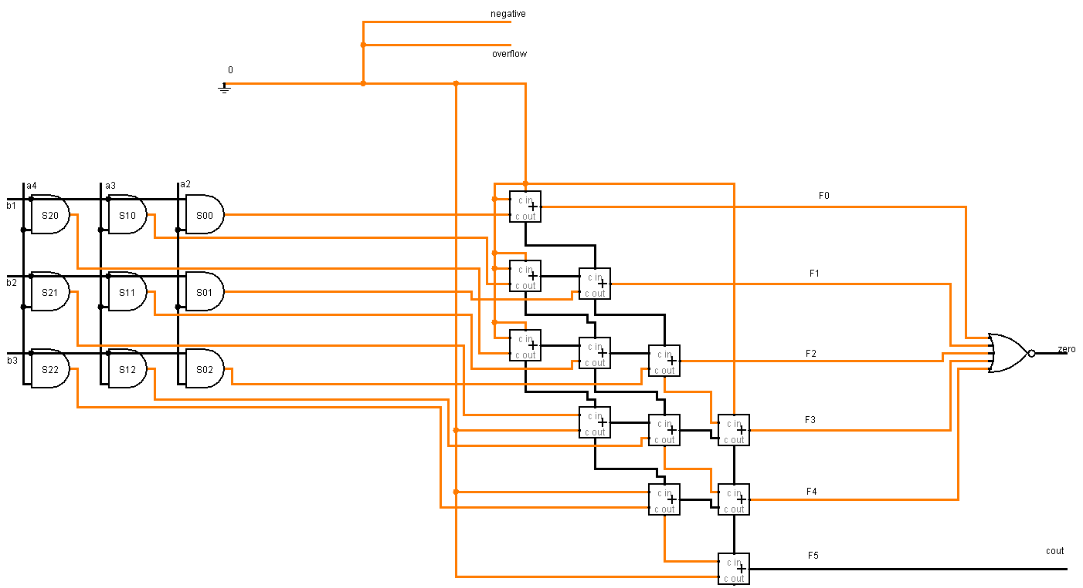

c)

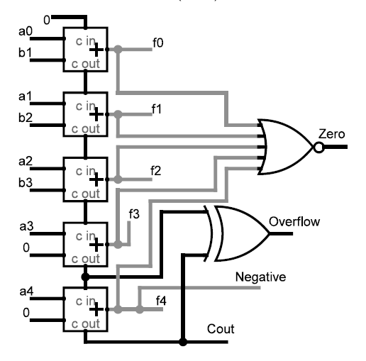

d)

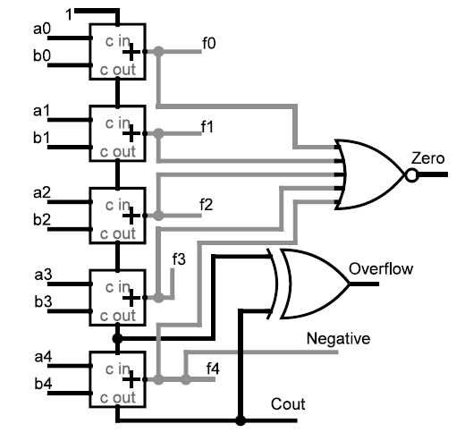

Step 2: Merge all operations with select inputs and organize outputs, Try to minimize your implementation by using repetitions, draw final circuit as the minimized final design of the ALU.

